

Beginner Hockey Program
Team Concepts Guide

By
Derek Henson
derekhenson@shaw.ca

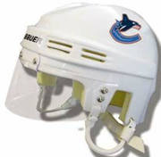

Table Of Contents

Tactical Strategy

-Defensive Zone………………………………………………..…….2

-Offensive Zone……………………………………………….……..9

-Neutral Zone Regroup/Counterattack……………………….…..…11

-Power Play…………………………………………………………13

-Penalty Killing…………………………………………………..…15

-Forecheck…………………………………………………………..16

-Face offs……………………………………………………………17

-Notes from Toughness Training for Sports……………………………...…19

-Glossary of Terms……………………………………………………….…20

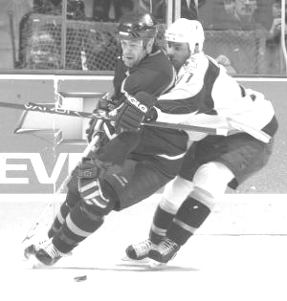“It takes brains. It's not like a forward, where you can get away with scoring and not play defense. On defense you have to be thinking.” - Chris Chelios

Defensive Zone

The Defense will be the first line, competing for loose pucks and winning one-on-one battles in the corners. The Center will be the second line of defense, playing between the puck and the net to help the D-man gain numerical superiority over opponents. It is the D-man’s job to pin the attacker in the corner and allow the Centre to retrieve the loose puck. The strong side winger will have his feet towards the near boards, near the top of the circle so that he can have vision of the puck and the point man that is his responsibility. The weak side winger will play in the high slot with his feet facing the same boards but turned slightly towards the blue line so that he can see both the puck and his point man. AS SOON AS YOUR TEAM GAINS POSSESSION, the wingers will retreat to their breakout spots at the hash marks near the boards. Positioning higher than the hash marks will prevent you from being able to breakout successfully away from the point man’s pressure. This could lead to an interception and a dangerous counterattack for your opponents. The wingers will be the safety outlets for the center if the center is pressured. The far side winger will explode across and high, through the point men to back them off the blue line and create space. If the D do not back off the line, a small chip or board pass will clear the zone and create a break for the weak side winger.

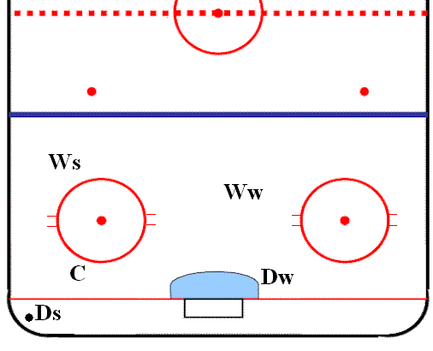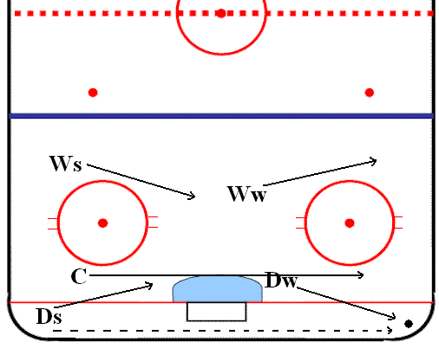

A) Individual Responsibilities:

Strong Side Winger (Ws)
- Covers point man on strong side. Cover Passing lane to the point.
- Skates are positioned away from net to enable you to see point man and the puck in the corner.
- Stay outside top of the circle and do not help down low.

Weak Side Winger (Ww)
- Sag into high slot and go all the way to the goal line if the opponent is open.
- Responsible for weak side point man.
- Position skates away from the net to see the point man, loose man in the high slot and the puck at the same time.

Centre (C)
- Supports the D-man (Ds) in the puck zone. Picks up loose puck after D-man has checked opponent.

D-Man on Puck Carrier (Ds) (Strong Side D)
- Closes gap on opponent and attempts to separate him from the puck to enable centre to gain possession.
- Contains puck carrier if puck carrier is facing him. (Do NOT charge at him)

D-Man Front of Net/Off Post (Dw) (Weak Side D)
- Stay within 1 stick length of opponent in front of net, between puck and opponent, and opponent and net. If there is no one in front, stay along far post.
- Do not get tied up with opponent.

B) When Puck is at the Point:

- Cover opponents from inside out if possible but do not get tied up with opponent.
- Be in a position that, when the shot comes, the opponents’ stick is off the ice and let the goaltender play the puck. Worry about your man, not the puck.
- Block out and allow no rebound shot. Clear puck to corner if loose puck occurs and you are 100% sure you can get to it
- Be strong and tough in front of the net without taking a penalty.
- Approach point man from the inside out with stick on the ice.

C) General Rules:
- If you find yourself out of position due to backchecking commitment, communicate with teammates when to switch.
- If you come up with the puck in your zone and you are out of position, take a whistle. (Freeze or ice puck)
- Scoring areas: force puck carrier and all other opponents away from “A”. “A” is considered the prime scoring area. Sacrifice single shots from “B”. Goaltenders are expected to control 100% of “B” shots.
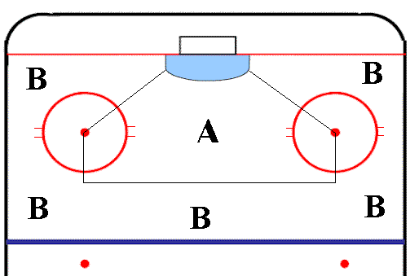

- Never give up the second shot. Give up the first shot rather than lose proper defensive coverage positioning.
- Return to the net first.
- If a teammate is beaten down low, play a zone type defense and force opponent to either shoot from a bad angle or pass into traffic until the team recovers.
- Never let the opposition get back into the play before you do.
- Establish defensive positioning when your team does not have the puck. Watch people not the puck.
- Emphasize blocking out defensively with your body.
- Emphasize, at all times, to take the defensive position in all scrambles all over the ice.

D) Playing a One on One in Your Own Zone

First key is to assess the level of puck possession your opponent has. This will help determine how quickly and aggressively you can approach the opposing player and which defensive techniques should be used. This determination must be learned so it becomes instant and instinctive.
Level | Position of Check (Opponent) | What YOU Do
Level 1 | Opposing player has full control of the puck with his head up and is looking toward the middle of the ice or the net | Attack at an angle, preferably driving the attacker down towards the end boards or goal line. If you attack head-on, the opponent can use a fake and skate either left or right. If you attack head-on (or straight) you give the opponent the advantage. If you approach at an angle, you take one option away from him/her. Your stick should be in front of your body, in one hand. As you approach the puck carrier, you must be prepared to extend your stick to execute a poke check or break up a pass attempt. Control the player and prevent him from continuing in the play.
Level 2 | The opposing player (puck carrier) has full possession of the puck but is facing the boards and is not completely aware of all play options available to him | You can play this one slightly more aggressively. Still approach at an angle, and drive the puck carrier towards the end boards. If the opponent turns around as you approach, quickly perform a poke check and block out to stop any momentum.
Level 3 | Puck is near the attacker’s stick, possible rolling along the boards or bouncing around between his skates | Be far more aggressive. Look to pin the body and allow a supporting teammate to regain possession of the puck. You may not need to angle but you should pin the body as soon as possible.

Breakouts

A) Breakout Rules When Not Set Up
- One D-man is always retrieving the puck.
- The other D-man, if possible, tries to screen out or slow down the opposing forecheckers, while communicating to his partner where to go with the puck.
- At all times, when in trouble, shoot the puck off the glass out of the zone.
- Always communicate with the goaltender and your D-partner.
- Goalie should also help with screening and communicating.
- Breakout of zone as quickly as possible, before the opposing D-men can get to the blue line.
- Create a 2 on 1 situation against the first forechecker by using an outlet for support.
- AVOID diagonal cross-ice passes.
- Forwards first responsibility is to screen out opposing players to buy time for your D-men, and then sprint to their positions.
- If, for some reason, a forward retrieves the puck deep in your zone, the D-man closest should sprint to the opposite corner for a pass then move the puck up quickly. (Forward should not skate behind the net with the puck).

B) Breakout Concepts
- Three options are available to the D-man in order to succeed in executing the breakout: Up, partner, or reverse.
- These options are to be called by the supporting D-man who is reading the pressure.

Pressure | Breakout to Execute
No forechecking pressure | Up: Turn up ice and pass puck to strong side forward.
Forechecking pressure that is on the strong side of the ice but not right behind the defenseman and/or not an immediate threat. | Partner: D to D pass below goal line to initiate breakout out of the weak side of the ice.
Forechecking pressure is on the strong side, seriously threatening puck-controlling D-man. | Reverse: Puck controlling D-man reverses puck behind the net to the other D-man who picks up puck and turns to the weak side of the ice to relieve pressure on the puck.

Regardless of the initiation of the breakout, the Center will support the side that the puck comes out of. This creates four options to the puck carrying D-man. He could either:
- Pass to winger along the boards
- Pass to the supporting Center
- Carry the puck out (If no pressure on him/her)
- Clear puck high and hard off the glass into the neutral zone.

C) Important Concepts: By Position

D-Man Who Picks Up the Puck:
- Get to the puck quickly – full strides, keep your feet moving.
- Read the checking pressure as you move to the loose puck to enable you to choose the best options.
- Face up ice as fast as possible.
- Read an option, don’t force an option.
- Protect the puck with your body if in trouble.

Free D-Man:
- Create as much time and space as possible for your partner by screening out the forecheckers.
- Don’t vacate (release) front of the net as an outlet until partner has possession of the puck.
- Communicate to partner and provide appropriate outlet.
- Always be aware to be an outlet for your partner.
- Follow play up the ice immediately (support).

Strong Side Winger:
- “Stride” back as soon as possible, ready to receive the pass. If D-man is being pressured, go down low to the hash marks and stop. Watch the puck at all times so you can read the option.
- If D-man is not being pressured go below the hash marks, use “open up” turn and head up ice. Vacate the area if D-man skates with the puck.
- The key play is to get the puck past the opposition’s D-man if he pinches. (Board pass) Get the puck to the neutral zone.
- Don’t turn your back to the puck.

Weak Side Winger:
- Do not vacate unless the puck is passed beyond goal line on opposite side.
- If the puck is passed to the opposite wing, “drive” skate up the ice inside opposition D-men as a pass option. Anticipate this and accelerate at top speed.
- Don’t turn your back to the puck.

Center:
- “Mirror” the puck carrier. “Save” ice by skating laterally below the dots in same direction as the puck.
- On the reverse, continue to “mirror” puck and reverse by curling high or low. (Low is preferable).
- If the opposition’s D-man “pinches” move to the site of the pinch from the “defensive side”.
- If the pass is made to the wing, position yourself so the winger can make a lateral or slightly behind pass to you. (You should normally be the last forward to leave the zone).

Defensemen’s Rules in the Neutral Zone
- Assess the situation and communicate with D-partner and back checker. Stick is ALWAYS on the ice.

Playing 1 on 1:
- Align your outside shoulder with your opponent's inside shoulder.
- Always be less than a ½ zone ahead of opponent. DO NOT give him room—close the gap. Force the play before reaching the blueline. If opponent cuts in, close in on him, DO NOT LUNGE!
- If opponent goes wide—angle and pressure to the boards. If you pivot too late—cut off the angle by skating to the nearest post of our own goal.

Playing 2 on 1:
- When the puck is approaching your blue line, force the puck carrier to pass or carry wide. (use body and stick deception)
- Always stay between the two opposing forwards with your back facing our goal. Stay between the circles width wise.
- Let the Goalie play the wide shot – you take the slot man if shot is taken. Keep your stick on the ice.

Playing 2 on 2:
- Play two 1 on 1’s.
- Keep forwards from switching by forcing outside the blue line and close in on the puck carrier.
- If you are caught flat-footed and their forwards are able to switch – then you and your D-partner switch.

Playing 3 on 2:
- Force the puck to the wide man outside the blue line.
- Strong side D-man takes the puck carrier – angle and close. Make sure to block the passing lane across the crease.
- Weak side D-man anticipates trailer and takes play away.
- Goalie must be alert for pass across crease.
- All D-men follow play up ice quickly – never be more than one line behind play so as not to get caught flat footed on turnover by forwards.

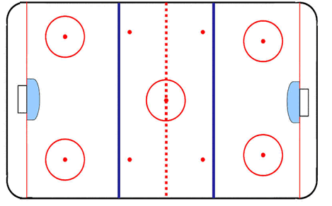

Controlling

the Middle

of the Ice

AT ALL TIMES, control the middle of the ice and force your opponents to carry the puck to the outside. This will eliminate space and attack options.

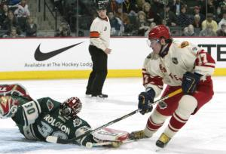
“A good hockey player plays where the puck is. A great hockey player plays where the puck is going to be.” –Wayne Gretzky

Offensive Zone

AT ALL TIMES, follow the 1-2-3 Principle of Attack.
Player | Significance | Responsibility of Player
1 | Puck Carrier | Read offensive support and defensive pressure.  Always be a threat to score. If there is no support (and the player is outnumbered), this player either delays to create time and space for support to arrive or dumps the puck into the quiet zone corner and forechecks hard to the puck.
2 | 2nd Player across blueline | Drive to the net in order to create pressure on the defensive players. This will create space for the puck carrier and the late forward coming in. If a D-man does not follow to the net, a pass through by the puck carrier will result in a scoring opportunity.
3 | 3rd Player across blueline | Read the position of 1 and 2 and stay high and open to support the puck. If a turnover happens and the opposition gains possession, this player will support the defense and take an open man all the way to your net, if necessary.

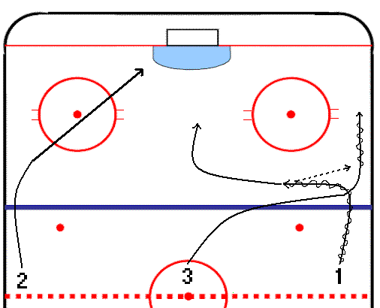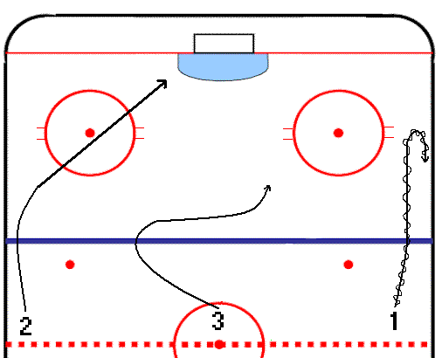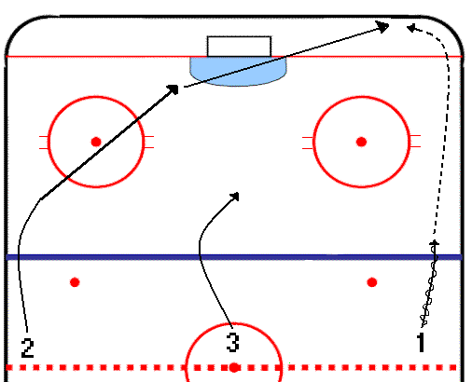

Chip Delay Quiet Zone

- Attacking the Blueline:
- The puck must end up deep in the offensive zone to enable your D-men to move up to the blueline for support.
- DO NOT turn the puck over anywhere between the blueline and the offensive hash marks.
- Read the defensemen. If they back in and give you the blueline, take the puck to the middle. If they stay up, try to drive outside or gain the blueline and perform a delay.
- If you are pressured and have no play, always put the puck past your checker so a teammate can skate into it.
- If you will be pinched off when you cross the blueline, use delay or dump puck into the quiet zone.
- If you are ahead of the play and don’t get the pass, don’t go offside but cut 3 feet in front of the blueline. Either pick an opposition D-man or continue to an open area or break to the opening once the puck has crossed the line.

- Offensively Down Low
- Protect the puck with your body at all times.
- Drive to the net whenever possible. Create havoc in the crease, especially your bigger forwards.
- Try to make plays before going behind the net off the short side post or stuff.
- Utilize space below goal line (quiet zone) whenever possible – especially space to opposite corner. Use the cycling concept – this will free up a forward in the slot for a scoring opportunity.
- D-men can come in to the depth of the opposition’s forwards. (If you see their numbers on their backs, pressure).
- If our D-men go in with the puck, the puck must get down to the goal line.

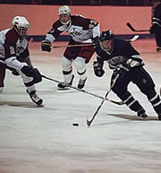

Neutral Zone Regroup/ Counterattack

A) General Rules
Your top priority is to counter quickly before the opposition can recover defensively. You can accomplish this by the following:
- Commitment to one touch passing.
- Emphasis on forwards getting back to support “D” with stick in ready position and feet ready to explode forward on transition from defense to offense. DON’T lose sight of the puck.
- Forward away from the puck goes to the weak sidewall as a quick outlet.
- D-man with the puck looks to advance the puck in immediate transition to an open forward. If there is no open forward, D-man looks to pass to his partner so we can come out the weak side.
- D-man NEVER shoots the puck back to the other team the same way it came unless absolutely necessary. It destroys the counterattack and gives the puck back to the opposition. Look for passing options.
- Nearest forward comes back towards D and mirrors the puck movement.
- Third forward mirrors higher and with a slight delay.

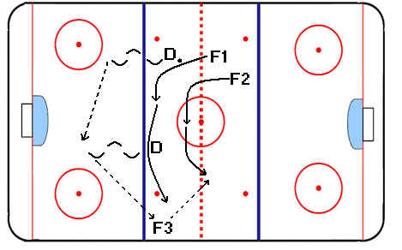
Regroup

Key considerations

Forwards:
- Always keep your eyes on the puck and make yourself available.
- “Save” ice by moving at the correct time.
- Keep your stick on the ice in ready position.
- It is not a race. Accelerate after the puck is head manned.
- Pass the puck softly to open ice if pressured. “Chip” the puck past opposing checkers.
- Don’t go offside! You are responsible for staying onside no matter what the situation is.

Defense:
- Our first option is a quick up (counter) before opponents can work their offense → defense transition.
- If first option is unavailable, pass back to D-partner. This will key forwards movement.
- If second option is unavailable, pass back to D-partner.
- Always back up partner for “defensive” passing lane.

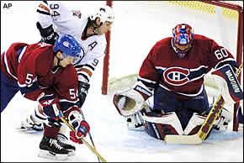

Power Play

A) Defensive Zone Rules:
- Breakout starts behind your net. D-man holds puck and waits for Center to curl low in the corner. Other D-man is low in opposite corner as an outlet as well.
- One winger is on the strong side blue line, other is at the far blue line to stretch the D in the neutral zone.
- As Center or outlet D-man get pass, the two wingers leave and move to support puck carrier.
- Speed is not as important as proper execution—You do not want to allow a turnover because of lazy or sloppy positioning and/or support.
- Move through neutral zone and gain space in the offensive zone so the D can set up on the blue line and your forwards can move to their places
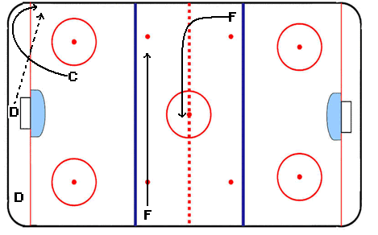
Power play Breakout

B) Offensive Zone Rules:
- Puck protection and support will be key.
- Only shoot when there is traffic if outside prime scoring area.
- One touch passes from low to high and side-to-side when possible.
- Two men on all loose pucks.
- D’s should step up at all times to keep the puck in.
- Try to out number the opposition down low.
- Patience with the puck—Don’t be forced into undue errors. PATIENCE DOES NOT MEAN CASUAL!

Power Play #1

One power play set play begins with the D-Man controlling the puck. The idea is to pull the winger away from the wall and towards the middle because the D looks like a threat to shoot. The D then passes the puck back to the strong side forward who is high on the wall. He wheels off the boards with speed. The two lower forwards step up and open up for a pass. The puck controlling forward has 3 options: Shoot, Pass to the forward to the left of the net, or Pass to the forward to the right of the net. His choice is determined by pressure. If pressure is applied to the puck carrier, then it leaves a low forward open. If no pressure then the forward skates in and shoots and the other two collapse for any rebounds.
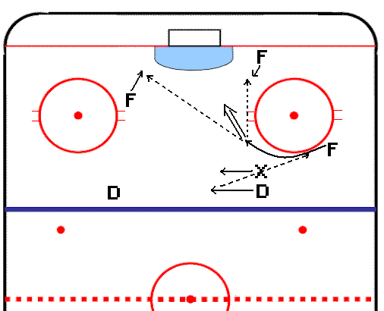

Power Play #1

Penalty Kill

Penalty killing is often the most inglorious job that a player can have. Success is truly defined by being able to prevent the opposition from scoring. When 5 on 4, play a box system with all four players playing passive and trying to prevent the puck from getting into the prime scoring area. Penalty killing is very disciplined.
General Penalty Killing Rules:
- Don’t let up – especially when they just enter your zone.
- Forwards approach the points inside out. D’s get ready to slide out in anticipation of puck movement.
- Sticks on the ice at all times positioned inside out. (Both hands)
- Play aggressively when checking in defensive zone to force the player to move the puck. Do not over commit; always stay between the attacker and your net so that you can get back into the play before the opponent.
- D-men should not try to move men in front of the net. Be in position to get his stick up if the shot comes. Keep your body free to move. Slide out for passes to the slot.
- If in trouble, freeze the puck.
- Clear the puck to near side off the board at knee level (on forehand only) 10 feet inside blue line. If you get near the boards, clear 15 feet in from blue line.
- If your D-men get possession in your zone – Fs cuts to the boards for passing angle while Fw flies out of the zone looking for a long pass.
- On dump ins, forwards take up position 5 feet inside your blueline at the boards for breakout.
- D-men follow play up the ice for scoring chance when you have the puck.
- Forwards keep shifts to 30 seconds. Don’t attempt a goal scoring chance after 30 seconds.
- Goalies must communicate to allow your players to know when you are back to even strength.
- Keep shifts as short as possible so you don’t get trapped with tired bodies. Penalty killing is gruelling!

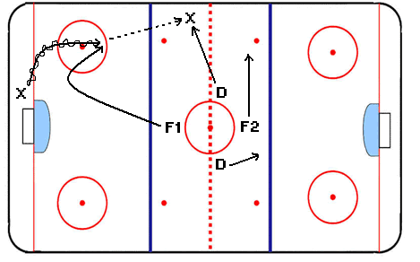
Penalty Kill Neutral Zone Trap

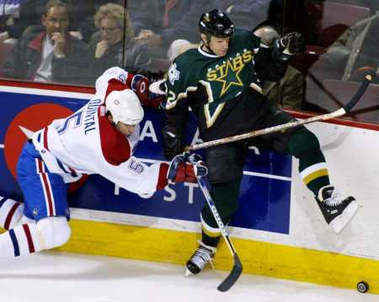

“They were checking us so closely, I could tell what brand of deodorant they were using." - Gary Dornhoefer

Forecheck

Forechecking Philosophies:

- Put as much pressure on opponents D-men with speed.
- First forechecker angles inside out, forcing the puck carrier up the wall.
- Second forechecker reads the first one and moves towards the outlet man on the strong side. He plays slightly passive and delays in getting to that player. This way, the puck carrier will try to pass it to this player and your second forechecker can take him out or cut off the pass and start a quick counterattack.
- Third forechecker covers the middle land and cuts off any passes through. If the opposition beats your forecheck, the third man backchecks and helps the D.
- NEVER let one pass beat two Forecheckers.
- Eliminate their first option of coming out the strong side – force opposition into making 2-3 passes to get out. (This will allow your second wave to get inside their blue line).
- If in doubt at all, make a defensive decision and start to backcheck.
- Have two players back at all times and preferably three. Don’t allow any 2 on 1’s, or 3 on 2’s off of a breakout.
- Effective dump-ins are critical. Attempt to leave the puck in the corner away from the Goalie (Quiet Zone).
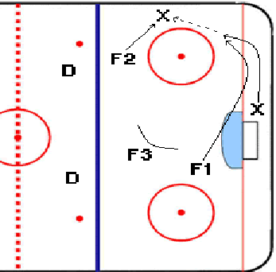
Offensive Zone Forecheck 1-2-2

Face Offs

Every face off you win allows you to control the play and execute a planned tactic. Have set face off alignments for every area on the ice. Some will be used at all times and some will be used when you need a goal.
- The Center will attempt to win the faceoff by drawing the puck to the bottom of the face off circle.
- The strong side winger will immediately skate hard through the circle, behind the opponent’s center, in case they try to draw the puck back. This way, you have immediate pressure on their shooter. If no one is there, the winger goes to his point man and covers
- The Defenseman along the boards will immediately come in to the circle, looking for the loose puck. He will gain possession of the puck and then skate hard behind the net, looking to execute a break out with the far side winger.

A) Defensive Zone Face offs

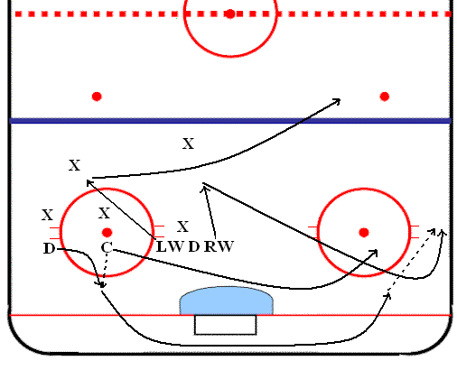

Offensive Zone Face offs

Face off on right→ side

←Face off on left side

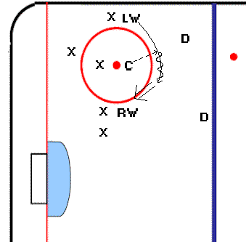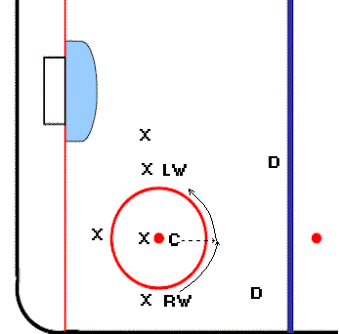

- Your goal is to create a scoring chance. Line up your wingers on the opposite sides (rw on the left side and vice-versa).
- The center will attempt to win the face-off by drawing the puck behind him.
- The winger on the boards will immediately skate towards the back of your center to get the puck. He will then wheel around the top of the circle to get a better angle to shoot at it. This player will shoot before he is pressured. The shot will ALWAYS be low if there is traffic in front of him.
- The other winger and center will lock onto their checks to buy time for the shooter.
- Note: The winger in front of the net must lock onto the other team’s winger.

C) Neutral Zone Face offs (Defensive)

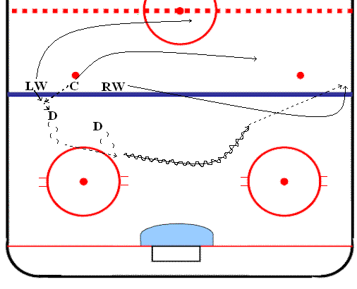
- Your priority is to try and win the face off to the wall. You can then pass the puck back to the D and initiate a regroup.
- The weak side winger goes to the far wall and your D make a D→D pass and then a pass to the outlet winger while the other two forwards swing in support.

D) Neutral Zone Face offs (Offensive)

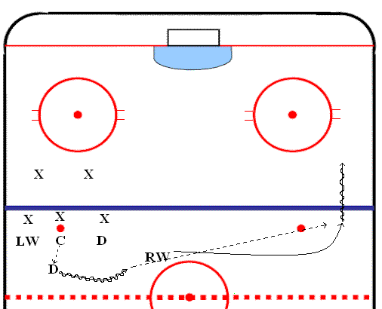
- Attempt to execute the Left wing or right wing carry.
- Inside D and winger will switch spots.
- The D man wants to win the puck back to the D man. The winger goes towards the far boards while still facing the puck.
- The D drags the puck to the middle and passes to wide winger who has time and space to gain the blueline.
- This winger either initiates an attack on the net or dumps the puck into the corner.

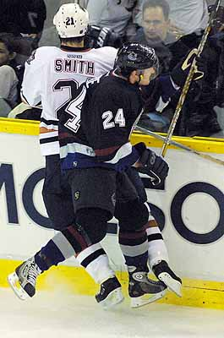
“It's not necessarily the amount of time you spend at practice that counts; it's what you put into the practice.” - Eric Lindros

Notes from Toughness Training for Sports- by James E. Loehr

Strategies for Getting Tough Mentally

A) Change Your Thinking – The way you’re feeling affects the way you’re thinking; the way you’re thinking affects the way you’re feeling. This is why great competitors are always disciplined thinkers. Mentally tough hockey players have learned to reverse the power of negative emotion by thinking tough and thinking positive.

B) If You Don’t Like the Feeling, Change the Picture- Images are far more powerful emotionally than words are. Thus, successful athletes constantly use images of success, of fighting back, of having fun, of staying relaxed, of being strong in the face of difficulties. The most powerful and important image you can have in your arsenal is your self-image. Work daily to make it strong, real, and courageous— and that’s exactly what you will get back in competition.

C) Practice Visualization Training Daily- Learn to picture things so realistically in your mind that you can actually hear, see, feel, and touch them. This represents an absolutely essential skill that is acquired through daily practice. Your brain is unable is unable to tell the difference between something vividly imagined and something that is actually real. That is why great hockey players are always great visualizers. They have learned to actually see themselves achieving important goals in their minds long before the actual game. Being prepared mentally and emotionally is nearly synonymous with visualization practice. A key to this is to visualize when you are relaxed.

Glossary of Terms

Weak Side- The side of the ice that the puck is NOT in. For example, if the puck is in the left corner, then the right side is the weak side.

Strong Side- The side of the ice that the puck is in. For example, if the puck is in the left corner, then the left side is the strong side.

Head on a swivel- Refers to the defensemen scanning the ice to read the pressure. Generally done looking left to right or right to left.

Read and React- When you read the movements of other players on the ice and react appropriately. Wayne Gretzky defined it best by saying, “A good player plays where the puck is; a great player plays where the puck is GOING to be”.

Delay- Generally used offensively by the puck carrier. Done by turning towards the boards to by some time for support to arrive.

Low and Slow- Generally refers to the movement the Center makes in the breakout when supporting the strong/puck side

Flat- Moving across the ice straight, parallel to the blue/red lines.

Quiet Zone- Behind the goal line and in the corner

Support- The player or players who help the puck carrier and become options for passes.

Wheel- Hard acceleration when there is lots of space and no pressure.

Active Stick- Usually done on penalty kill. Refers to moving stick back and forth on the ice to take away passing lanes.

Contain- A passive way to check an opponent by prevent space but not body checking.

Pick- Moving into space that a defender is travelling towards in order to block him from checking your teammate who has the puck.

Drive- Skating hard, with or without the puck, in such a way that you are a threat offensively.

Pin- Securing an opposing player on the boards to allow a teammate to come in and take the puck.

Ready Position- Knees bent, both hands on the stick, stick on the ice (always ready).

Transition- The change from offense to defense or vice-versa.

Screen Out- Not to be confused with a “screen”, as in screening the goalie. Screening out is blocking out opposing skaters for a brief time to buy time for a teammate. This is done mostly with body position but never with any aggressive body contact that would result in an interference penalty.

